User Story

1.

2.

3.

4.

User Story Mapping

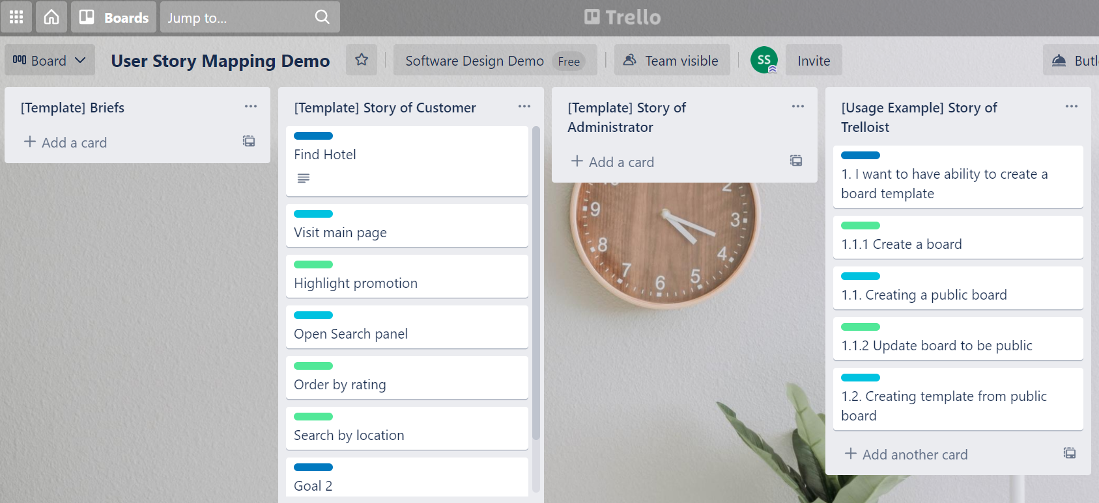

User Story 1